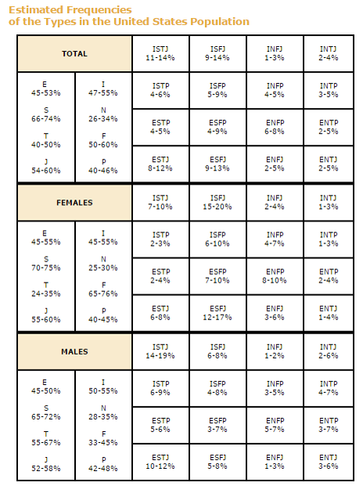

|  |  |  |  |
| --- | --- | --- | --- |
| ISTJ – Logistician  SJ Sentinel | ISFJ – Defender  SJ Sentinel | INFJ – Advocate  NF Diplomat | INTJ – Architect  NT Analysts |
| ISTP – Virtuoso  SP Explorer | ISFP – Adventurer  SP Explorer | INFP – Mediator  NF Diplomat | INTP – Logician  NT Analysts |
| ESTP – Entrepreneur  SP Explorer | ESFP – Entertainer  SP Explorer | ENFP – Campaigner  NF Diplomat | ENTP – Debater  NT Analysts |
| ESTJ – Executive  SJ Sentinel | ESFJ – Consul  SJ Sentinel | ENFJ – Protagonist  NF Diplomat | ENTJ – Commander  NT Analysts |

**MBTI Function Stacks**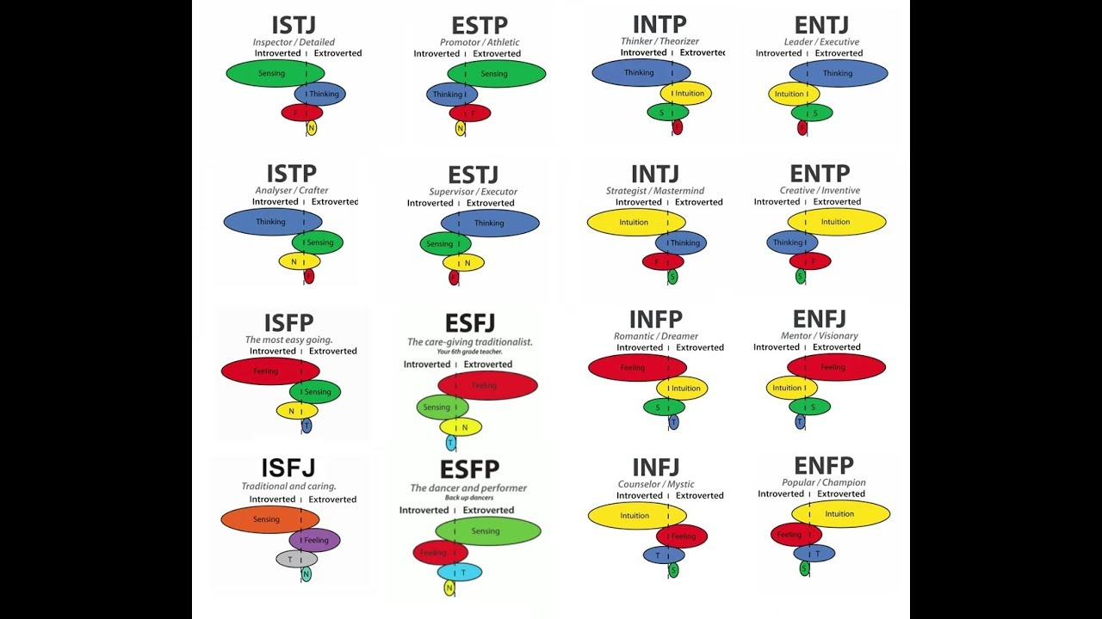

First (dominant) Function: the person’s main way of interacting with the world.

Second (Supporting) Function : An important part of a person’s personality.

Which ever of the first two functions is extroverted will be how others perceive you. Ex: INTJ and ENTJ both have Ni and Te as their top two stack functions and both will seem like “thinky” people. Even though for an INTJ, Te is secondary.

Third Function: Serves as a pressure valve or challenge area.

Fourth (Inferior) Function: May be an Achilles heel or a hidden strength. Least developed.

|  |  |  |  |
| --- | --- | --- | --- |
| ISTJ – Si Te Fi Ne | ESTP – Se Ti Fe Ni | INTP – Ti Ne Si Fe | ENTJ – Te Ni Se Fi |
| ISTP – Ti Se Ni Fe | ESTJ – Te Si Ne Fi | INTJ – Ni Te Fi Se | ENTP – Ne Ti Fe Si |
| ISFP – Fi Se Ni Te | ESFJ – Fe Si Ne Ti | INFP – Fi Ne Si Te | ENFJ – Fe Ni Se Ti |
| ISFJ – Se Fe Ti Ne | ESFP – Se Fi Te Ni | INFJ – Ni Fe Ti Se | ENFP – Ne Fi Te Si |